BIO-482 – Miniproject 2023 (Weeks 10-14)

The miniproject is a Matlab- or Python-based analysis of membrane potential data from Dr. Taro Kiritani (Kiritani et al., https://dx.plos.org/10.1371/journal.pone.0287174 ).

There will be a total of 10 marks for the miniproject, counting towards 1/3 of your final grade.

- in Room AAC137

Week 10:

Friday 17 November, 13:15-14:00 – Miniproject introduction (Carl Petersen)
Friday 17 November, 14:15-15:00 – Miniproject objectives and guidelines (Sylvain Crochet)

Before Friday 17 November please download:

The MiniProject_DATA and CODES for Matlab and Python (< 5 GB) can be downloaded from the Google Drive:
https://drive.google.com/drive/folders/0ALc1PIvbCTdKUk9PVA

The Maltlab and Python codes can also be downloaded from Github:
https://github.com/LSENS-BMI-EPFL/bio482_miniproject

Weeks 11-14 (Wednesday 22 November to Wednesday 20 December):

Wednesday and Friday, 13:15-15:00 – individual assistance on analysis in Room AAC137 (Sylvain Crochet and TAs).

Before 22 December (24:00) send your individual Miniproject report by email to (Sylvain Crochet, sylvain.crochet@epfl.ch)

We will use Matlab/Python codes to analyze the membrane potential recordings from cortical neurons. You will use these analyses to answer the questions at the end of this document.

Setting up:

Matlab:
- Download and install Matlab
- Add the /matlab folder to your MATLAB path to run the code.
- Make sure you also have installed the following:
* Signal Processing Toolbox
* MATLAB Curve Fitting Toolbox
* Statistics and Machine Learning Toolbox

You must add folders to MATLAB's path: Right-click on folder => Add to path/Selected folders and subfolders...

Python:
- You need to have Anaconda installed for your system: install anaconda here.
- Once Anaconda is installed, open a terminal and install a "bio482" conda environment: conda create -n bio482 numpy scipy matplotlib seaborn h5py pandas jupyterlab statsmodels scikit-learn
- Close terminal to make the conda environment effective.
- Make sure the environment is installed. Open a terminal: conda env list. The "bio482" environment should be there.
- Then, to work on the project:
- Go to python and open a terminal
- Activate the environment: conda activate bio482.
- Then run: jupyter lab.
- Open notebooks to start working on the project.
- To run the dataviewer.py, edit the file by replacing the location of MiniProjectData.mat to where your current .mat file is (i.e. full path).
- In jupyter notebooks, you must change paths based on where you cloned this repository.

Data visualization

Matlab version:
Run the code ‘DataViewer.m’ and use the graphic interface to select a neuron and a sweep to visualize. The GUI will plot, from top-to-bottom: the membrane potential (black), the right-whisker angle (green), the whisking times, the quiet times and the active contact times.

Python version:
To run the dataviewer.py, edit the file by replacing the location of MiniProjectData.mat to where your current .mat file is (i.e. full path).

Part 1 – Properties of cortical neurons during quiet wakefulness

Matlab version: run the codes ‘MiniProject_part1_Analysis.m’ then ‘MiniProject_part1_Figures_Tables.m’.

Python version: run the ‘Miniproject_Part1_Analysis_Figures.ipynb’ notebook.

Part1-a. Suprathreshold activity (firing of action potentials)

Action potentials (APs) – the suprathreshold activity – are high-amplitude and fast events generated by active conductances when the membrane potential (Vm) reaches a threshold for AP initiation. APs can be isolated from the background Vm fluctuations – the subthreshold activity – mostly composed of postsynaptic potentials.

In this first part, we will detect and isolate the APs in the Vm recordings based on the rate of change of the Vm (1st derivative) and their amplitude. The time of each AP will be defined by the time at its peak (maximum Vm).

Using “free whisking” sweeps – periods devoid of active contacts between the whisker and the object – from each cell, we will detect the APs and compute the mean firing rate in Hz for each cell. Then we can also compute the mean firing rate for each cell type (EXC, PV, SST, VIP).

The AP waveform is often used to classify cell types. In this second part we will try to measure basic AP properties for each neuron.

The AP threshold is generally considered as the initial time of the AP. AP threshold can be computed in different ways. Here, we will consider that the AP threshold corresponds to the time/Vm when the Vm instantaneous change (1st derivative of the Vm) crosses a threshold. In most of the cortical neurons, the instantaneous Vm change at the initiation of an AP exceeds 10 V.s⁻¹ (which is generally faster than the maximum Vm change for a synaptic event). Here we will use a specific threshold for each cell (data.Cell_APThreshold_Slope).

Using the same ‘free whisking’ sweeps, we will compute the AP threshold (the Vm at AP initiation time) for each AP. Then we will compute the mean AP threshold for each cell and each cell class.

Once the AP threshold time determined for each AP, we will compute the mean AP duration for each cell. For each AP, we compute the AP amplitude as the Vm difference between AP peak and AP threshold. Then we determine (approximate) the time when the Vm crosses the AP Vm at half-amplitude (AP threshold+AP half amplitude) in the rising and decaying phase. The AP duration is the difference in time between the two.

Thus, we can compute the mean AP duration for each cell and each cell type.
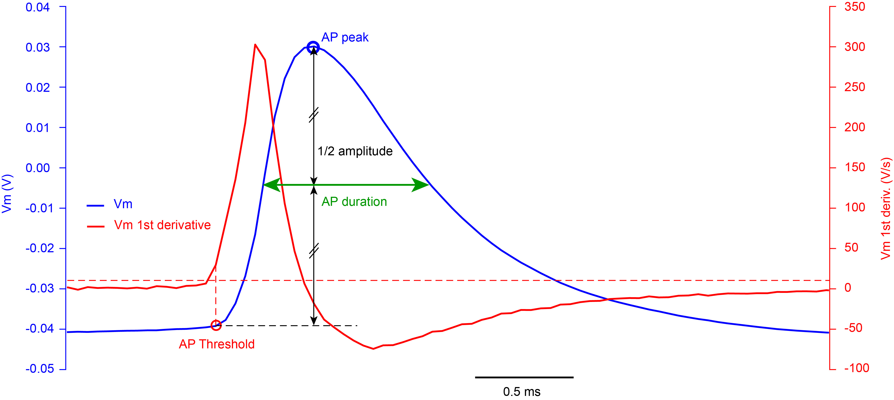

AP threshold, peak and duration. Membrane potential (blue) and its 1st derivative (red) around one AP. The red dashed line shows the threshold applied to the 1st derivative to define AP threshold (10 V/s). The AP duration is defined as the duration at half amplitude.

Part1-b. Subthreshold activity

Membrane potential recordings allow to access the subthreshold activity of the recorded neuron. The subthreshold activity is determined by the complex interplay between the intrinsic properties of a neurons (input resistance, capacitance, different active conductances) and its synaptic inputs. Here we will try to characterize some basic aspects of the subthreshold activity of the recorded neurons.

First, we will limit the impact of the suprathreshold activity on our measurements by ‘removing’ (cutting) the APs. Using the codes written to extract the APs, we will identify each AP and the AP threshold, and cut each AP using a linear regression between the AP threshold and return to baseline. Then, from the Vm trace after AP cutting, we will compute for each cell the mean and standard deviation of the Vm using non-overlapping 2 s time-windows.

Using the ‘free whisking’ sweeps, we compute the mean Vm and mean SD of the Vm for each cell and then each cell type.

Membrane potential dynamics can be described in the frequency domain using spectral analysis. A commonly used method is to compute the Fast-Fourier Transform (FFT) of the signal (the Vm in our case). Because Vm fluctuation is not a stationary signal, one should not compute the FFT for the continuous Vm recording but instead compute the FFT for shorter time windows and averaged the FFTs. Here we will compute the FFT for consecutive, non-overlapping, 2 s time windows for a ‘free whisking’ trial, then average the FFTs to obtain the mean FFT for a given cell. To quantify and compare the FFT, we can compute the mean FFT amplitude in a given frequency band.

Using the ‘free whisking’ sweeps, we compute the mean FFT for each cell and mean FFT for each cell class. Then we compute the mean FFT amplitude in the low-frequency (1-10 Hz) band.

________________________________________________________________________

Part 2. Membrane potential dynamics and motor activity

Matlab version: run the codes ‘MiniProject_part2_Analysis.m’ then ‘MiniProject_part2_Figures_Tables.m’.

Python version: run the ‘Miniproject_Part2_Analysis_Figures.ipynb’ notebook.

What is the impact of motor activity on cortical activity? We can correlate the cortical activity with the mouse whisker motor activity by comparing the Vm dynamics of cortical neurons when the mouse is not moving its whisker (Quiet) and when the mouse actively moves its whisker (Whisking). Here we will use whisking onset times during ‘free whisking’ sweeps to evaluate the impact of whisker movements on neuronal activity across cell types.

We will first assess the impact of whisking on subthreshold Vm dynamics (Vm after cutting the APs). We will compute the averaged Vm response triggered by the onset of whisker movements for each neuron. To do that, we cut the Vm 500 ms before and 500 ms after each whisking onset time, across all the ‘free whisking’ sweeps. Then we average all the Vm epochs to obtain the whisking onset-triggered Vm average for each neuron. We will use only whisking episodes lasting for at least 200 ms and not preceded by another whisking episode 500 ms before.

Then, we can compute the change in mean Vm after whisking onset. The change in mean Vm will be computed as the difference between the mean Vm 0 to 200 ms after whisking onset and the mean Vm 500 to 300 ms before whisking onset.

Next, we will compute the change in mean firing rate after whisking onset. For each neuron, we will compute the mean firing rate 500-300 ms before (FR before) and 0-200 ms after (FR after) each whisking onset time, and the change in firing rate (FR after –FR before).
________________________________________________________________________

Part 3. Sensory evoked neuronal activity

Matlab version: run the codes ‘MiniProject_part3_Analysis.m’ then ‘MiniProject_part3_Figures_Tables.m’.

Python version: run the ‘Miniproject_Part3_Analysis_Figures.ipynb’ notebook.

Up to here, we have analyzed the neuronal activity in the absence of sensory inputs, comparing periods when the mouse was immobile (Quiet) or moving its whisker in the air (Whisking) in ‘free whisking’ sweeps. In other sweeps, the mouse was presented with an object (a small metal pole) on its right side, positioned in the path of the C2 whisker. By moving its whisker forward, the mouse can actively contact – touch – the pole, generating active sensation. These active contacts are encoded in the activity of L2/3 barrel cortex neurons. In this last part of the mini project, we will investigate sensory coding for active touch in the different classes of neuron.

First, we will compute the averaged subthreshold Vm response triggered by the onset of active touches for each neuron. To do that, we will select ‘active touch’ sweeps for a given neuron and cut the Vm 200 ms before and 200 ms after each contact onset time. We then average all the Vm epochs to obtain the contact-triggered Vm average for each neuron. We will select only active contacts that were not preceded by another contact 200 ms before (inter-contact interval > 200 ms).

Finally, we will quantify the sub- and supra-threshold evoked responses by comparing the changes in mean Vm (post-synaptic potential amplitude) and in mean firing rate, 50-0 ms before to 0-100 ms after contact onset.

________________________________________________________________________

Part 4. Personal question

In this last part of the Miniproject, you will devise your own question to study and write codes to answer it.

BIO-482 Miniproject Report

Family Name:

First name:

SCIPER:

Question 1 (1/10 marks).

Based on what you have learned during the course, explain what could be the impact of the AP threshold, the mean Vm and the SD of the Vm on the mean firing rate of a neuron.
Based on the analyses performed in Part 1, identify which property(ies) actually influence the mean firing rate of cortical neurons across cell-classes? Justify your answer with some graphs.

Question 2 (2/10 marks).

What are the specificities of each class of cortical neurons allowing to best distinguish excitatory vs inhibitory neurons? and between the different subclasses of inhibitory neurons? Justify your answers with some graphs.

Question 3 (1/10 mark)

Summarize what happens at whisking onset time and active-contact onset time for the different cell-classes. Justify your answers with some graphs.

Question 4 - Your personal project (6/10 marks):

If you have done the project in group, indicate the names of the group members here:

Explain in a few lines what is the question you want to address, what is the rational and what is your hypothesis?

Explain briefly what analyses you have done to answer your question and how you have proceeded.

Present your results with some graphs and explanations.

Interpret your results, answer your question if possible or explain why you cannot, conclude.

Some ideas of personal questions:

- build a classifier to identify cell-classes
- spike history: how inter-spike interval impacts firing threshold or the Vm dynamic before spike initiation (slope of the Vm just before AP threshold)
- Layer/cell depth dependency: how neuron properties change with cell-depth/layer (that works well for passive properties and changes at whisking onset time)
- Cortical column dependency: how the response to active contact changes as a function of the cell position relative to the principal barrel column (C2 barrel column) (possible with only EXC cells, maybe PV cells)
- Compare Vm properties for quiet and active states
- Impact of inter-contact interval on sensory evoked responses
- Relationship between the reversal potential of the sensory-evoked response and the change in firing rate for active-contacts (should focus on EXC and PV cells)
- Investigate burst firing (large depolarizing potentials): proportion of neurons displaying burst firing in different cell classes.
- Identify spikelets (a few mV spike events) as possible indicator of gap junction coupling.

